Manometer
# Source: AI Source: Provided by: [Data Path: Persons Table -> ID Column: 1, Name_En Column: Motasem Essam] -> From: [ChatGPT] on [7/17/2026]
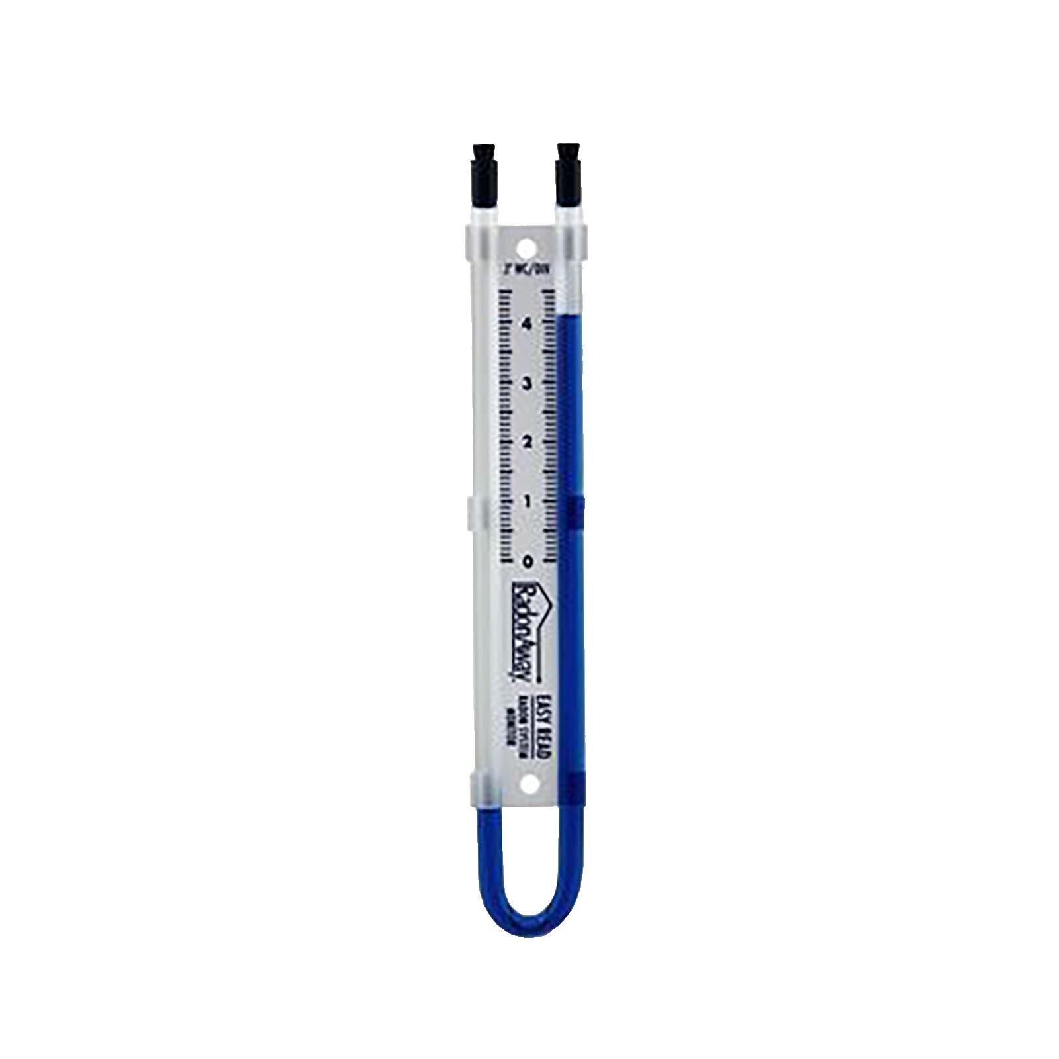
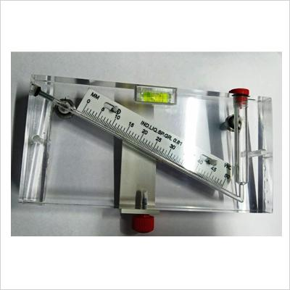
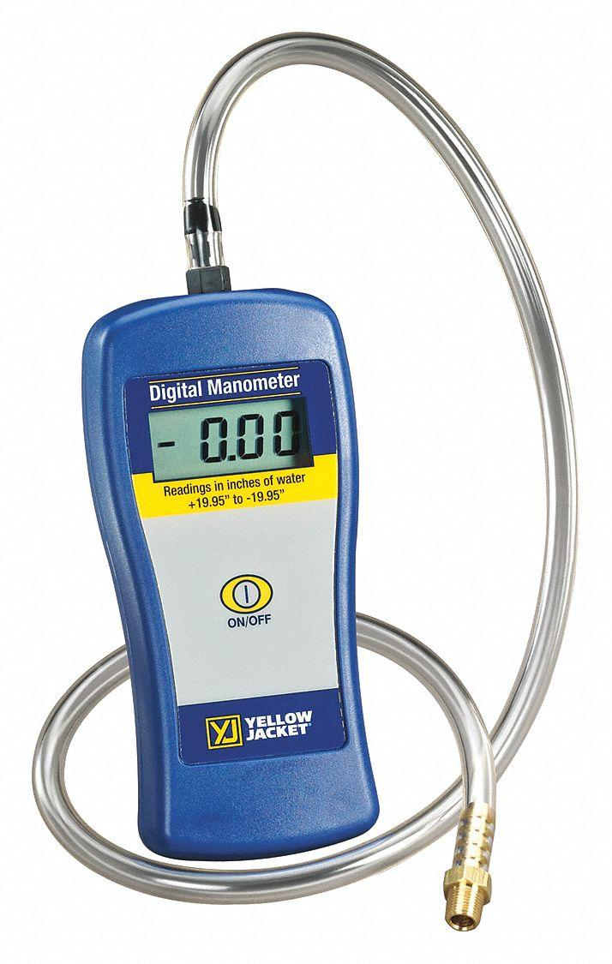
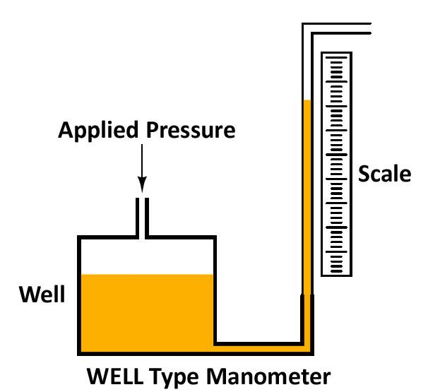
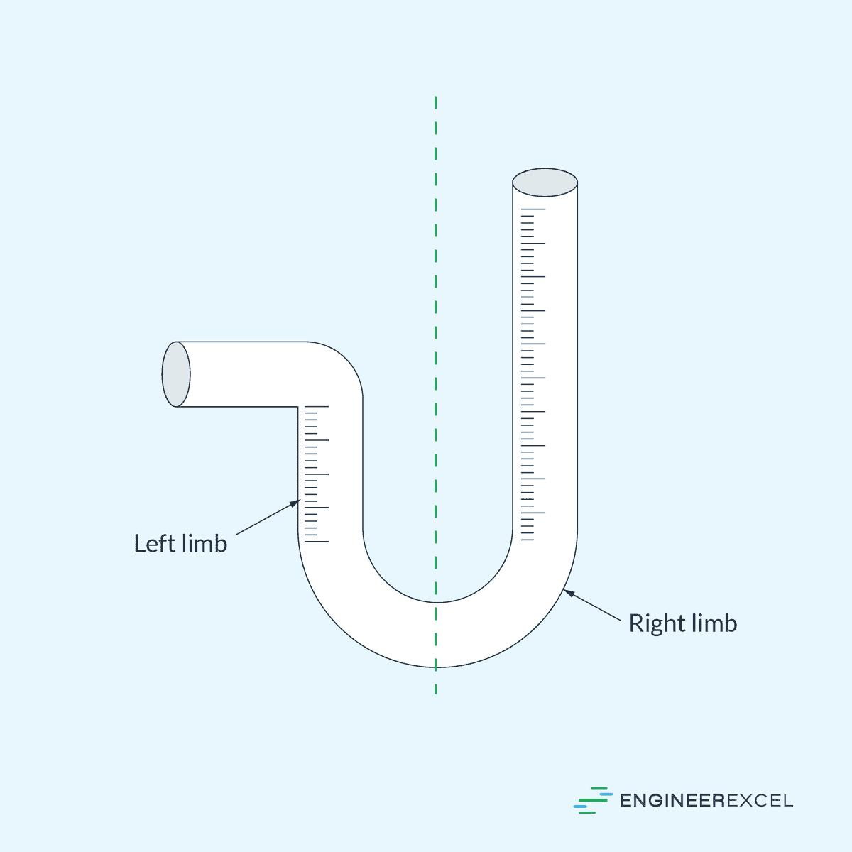
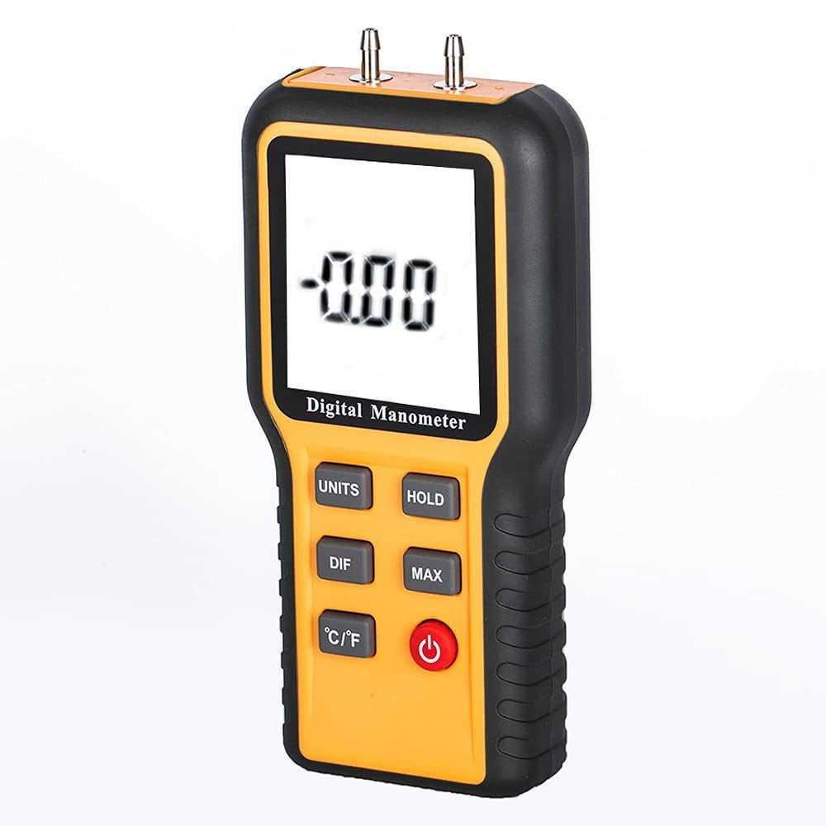
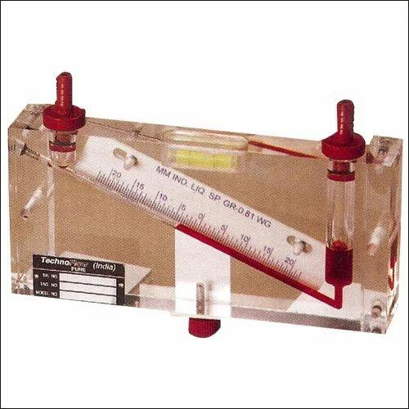
A Manometer is a pressure-measuring instrument that determines the pressure of a gas or liquid by measuring the height difference of a liquid column or by using an electronic pressure sensor. It is commonly used for measuring low pressures, differential pressures, vacuum, and gas pressure in laboratories, HVAC systems, industrial processes, and calibration work.

Definition
# Source: AI Source: Provided by: [Data Path: Persons Table -> ID Column: 1, Name_En Column: Motasem Essam] -> From: [ChatGPT] on [7/17/2026]
A Manometer is an instrument used to measure fluid pressure by balancing it against the pressure exerted by a column of liquid or by an electronic pressure sensor.

Purpose
# Source: AI Source: Provided by: [Data Path: Persons Table -> ID Column: 1, Name_En Column: Motasem Essam] -> From: [ChatGPT] on [7/17/2026]
A manometer is used to:
- Measure gas pressure.
- Measure liquid pressure.
- Measure differential pressure.
- Measure vacuum.
- Calibrate pressure instruments.
- Monitor airflow in ducts.

Principle of Operation
# Source: AI Source: Provided by: [Data Path: Persons Table -> ID Column: 1, Name_En Column: Motasem Essam] -> From: [ChatGPT] on [7/17/2026]
A manometer operates according to the principle of hydrostatic pressure.
When pressure is applied:
- The liquid column rises or falls until equilibrium is reached.
- The height difference corresponds to the applied pressure.
Digital manometers use electronic pressure sensors instead of liquid columns.

Main Components
# Source: AI Source: Provided by: [Data Path: Persons Table -> ID Column: 1, Name_En Column: Motasem Essam] -> From: [ChatGPT] on [7/17/2026]
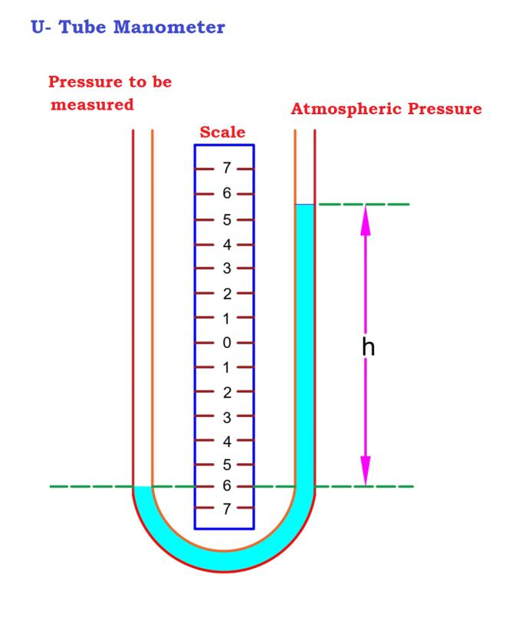
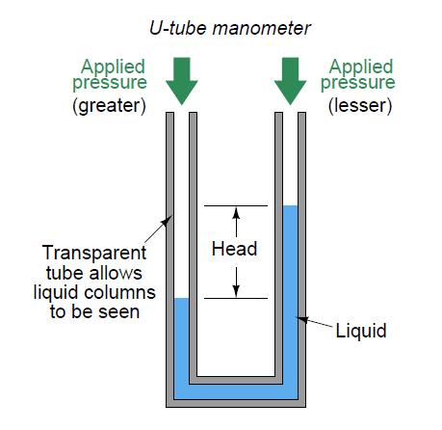
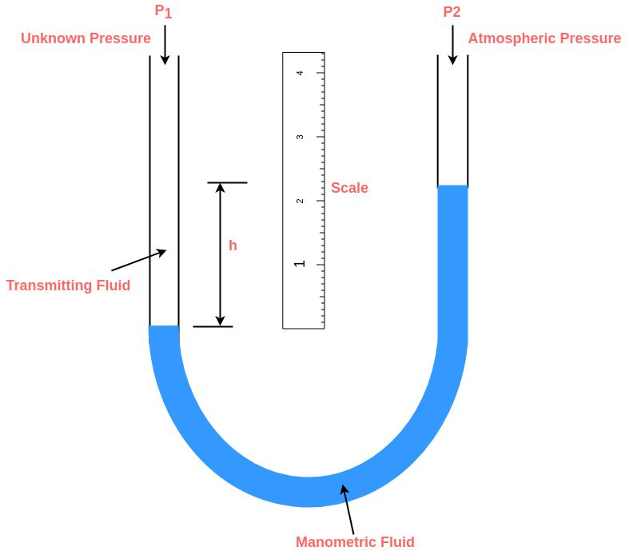
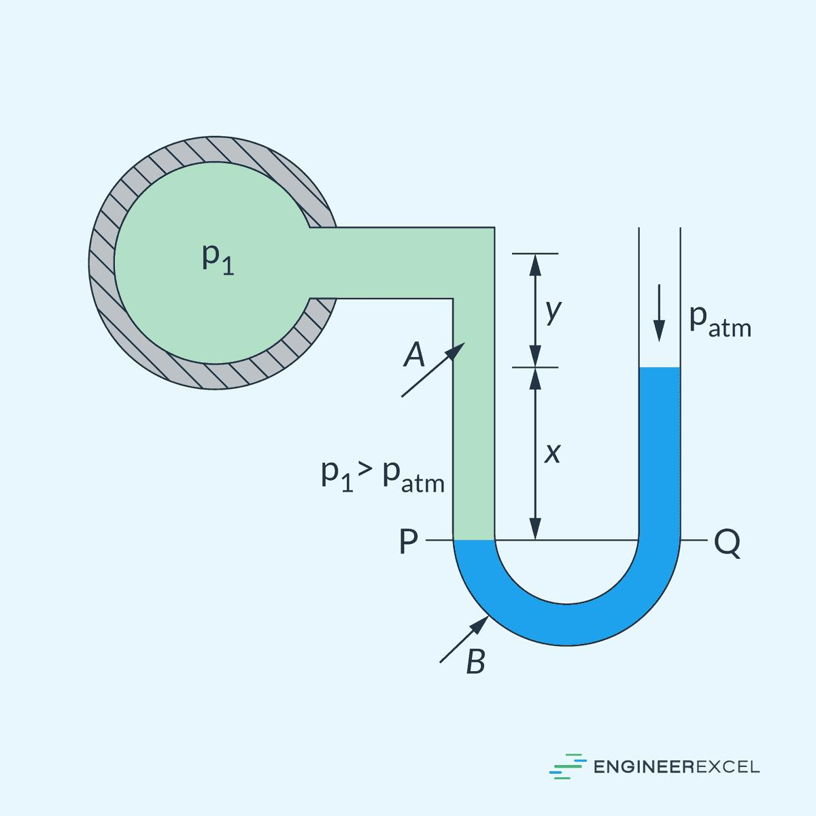
A typical manometer consists of:
- Measuring tube
- Working fluid (water, mercury, or oil)
- Scale
- Pressure connection ports
- Reservoir (well-type models)
- Digital sensor (digital models)

Types of Manometers

1. U-Tube Manometer
# Source: AI Source: Provided by: [Data Path: Persons Table -> ID Column: 1, Name_En Column: Motasem Essam] -> From: [ChatGPT] on [7/17/2026]
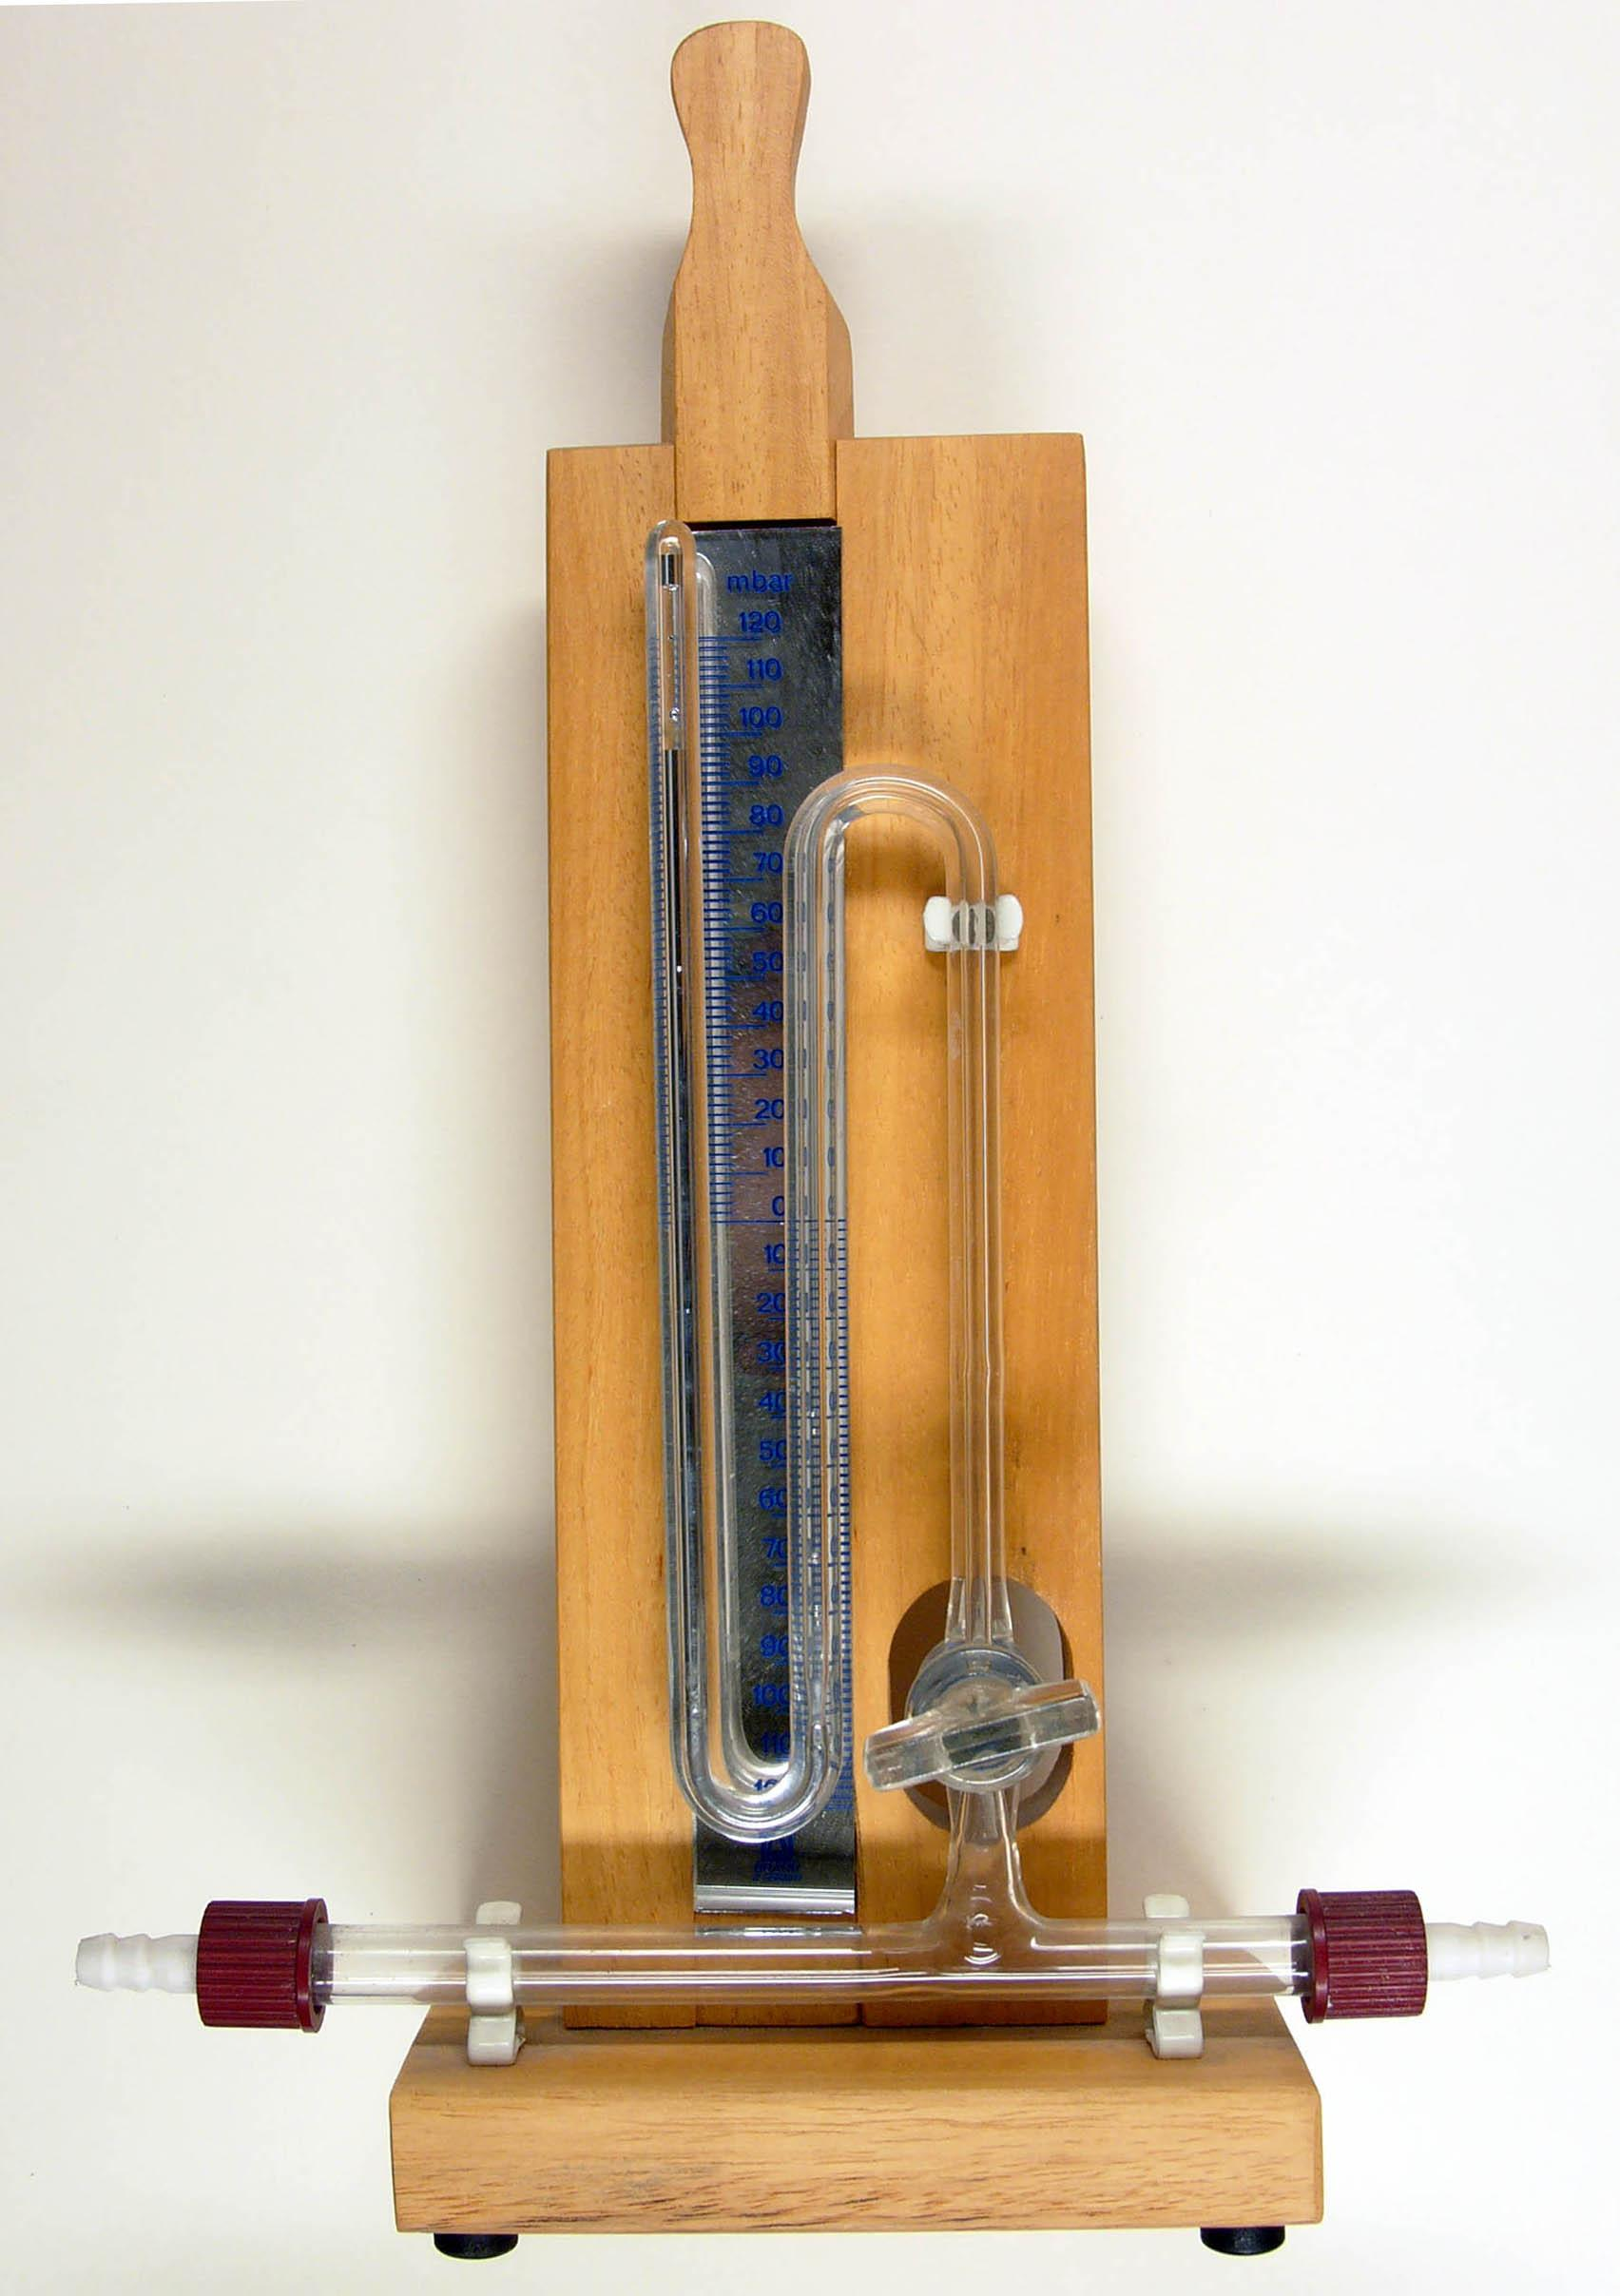
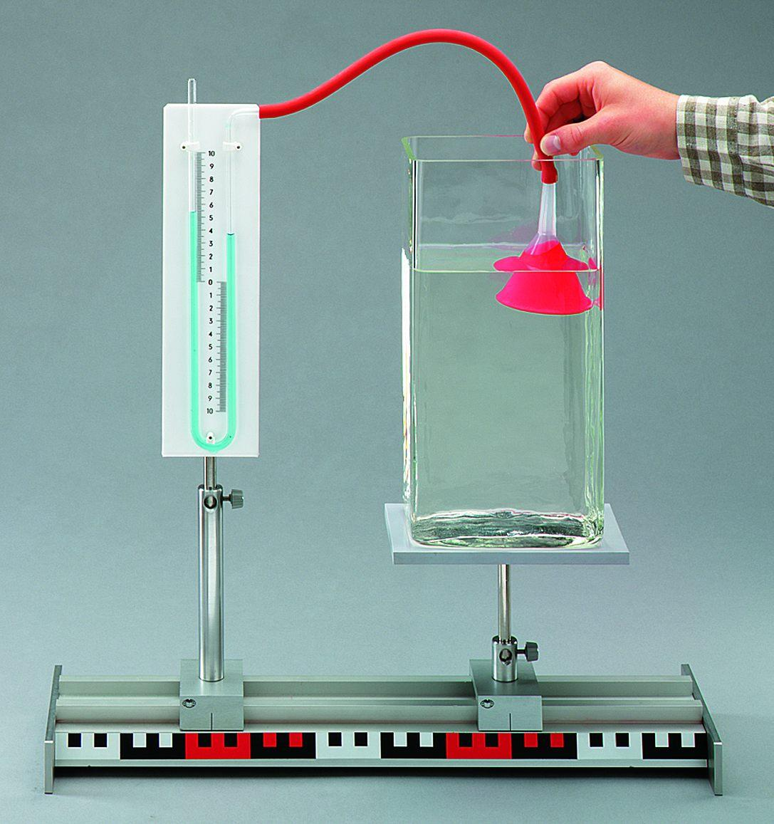
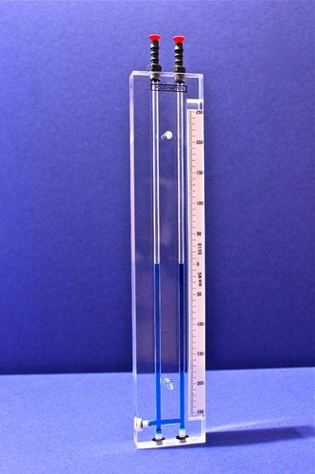
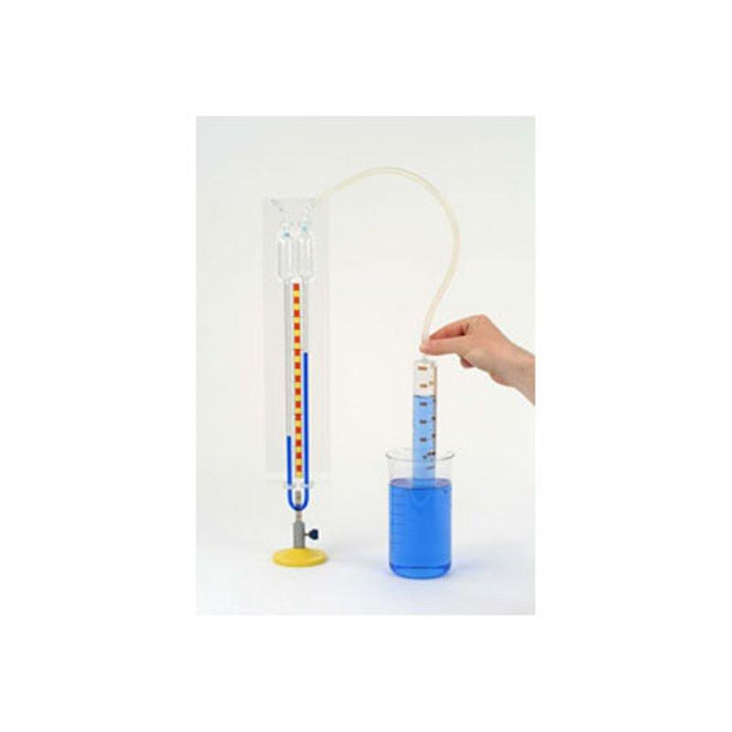
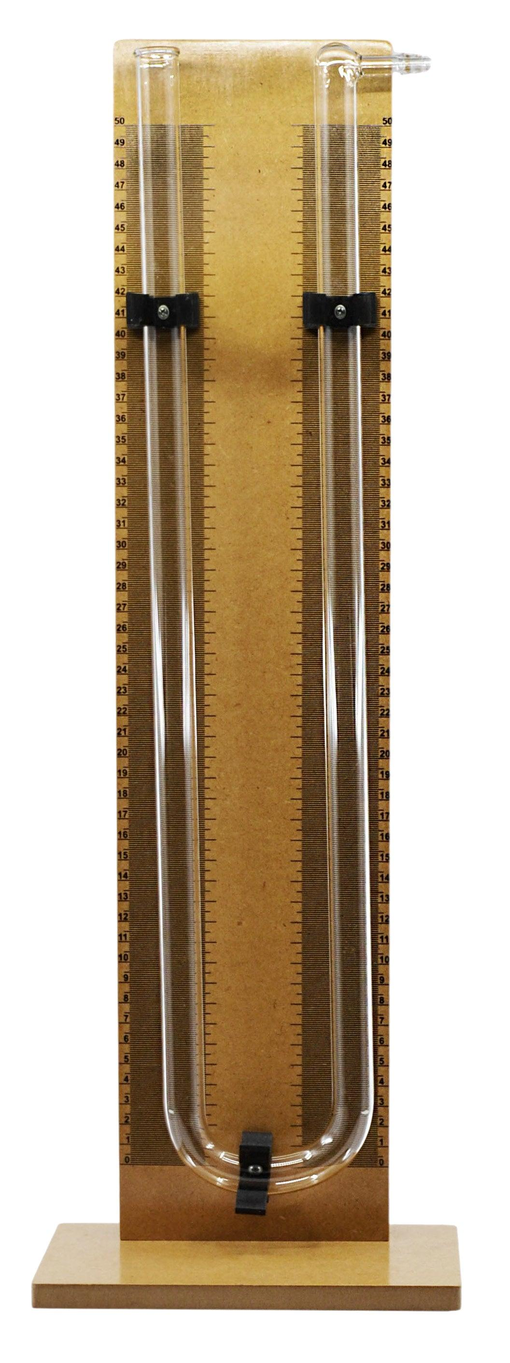
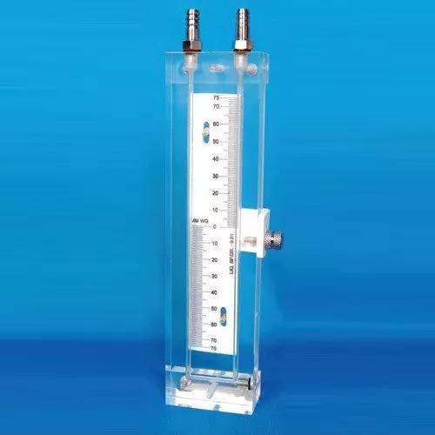
Description
The simplest and most widely used manometer, consisting of a transparent U-shaped tube partially filled with a manometric liquid.
Applications
- Laboratory experiments
- Pressure calibration
- Fluid mechanics

2. Inclined Manometer
# Source: AI Source: Provided by: [Data Path: Persons Table -> ID Column: 1, Name_En Column: Motasem Essam] -> From: [ChatGPT] on [7/17/2026]
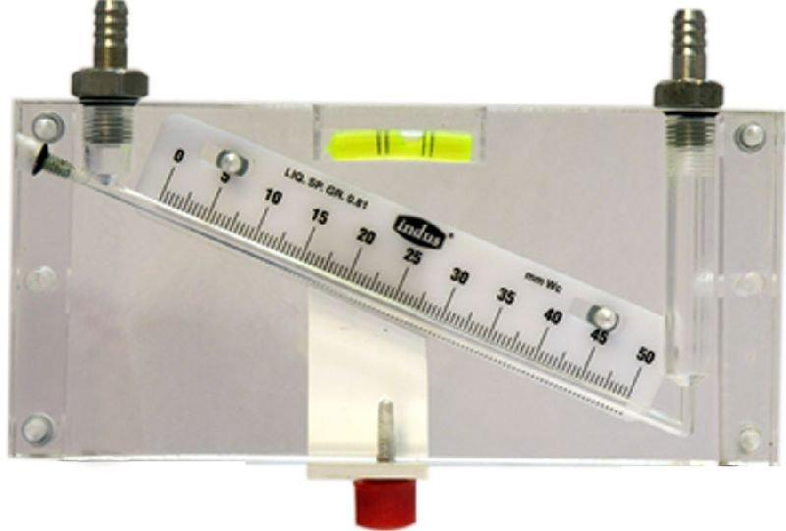
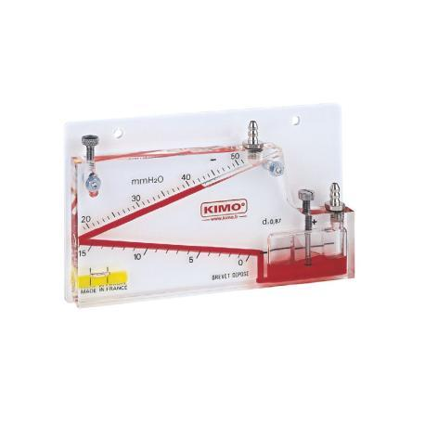
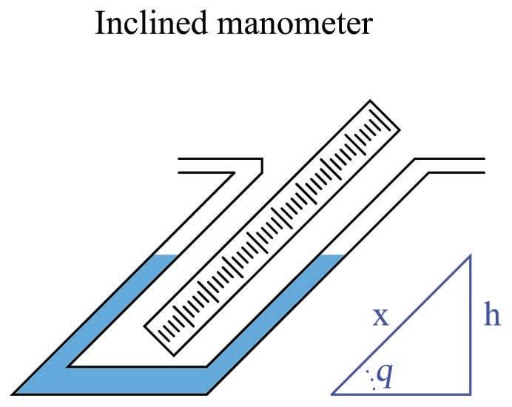
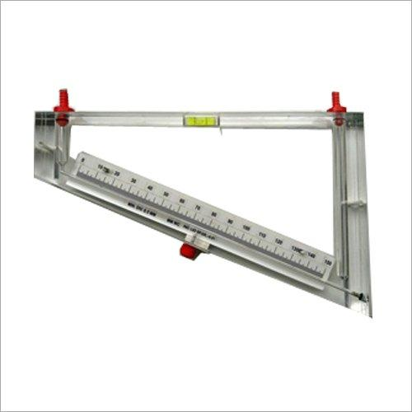
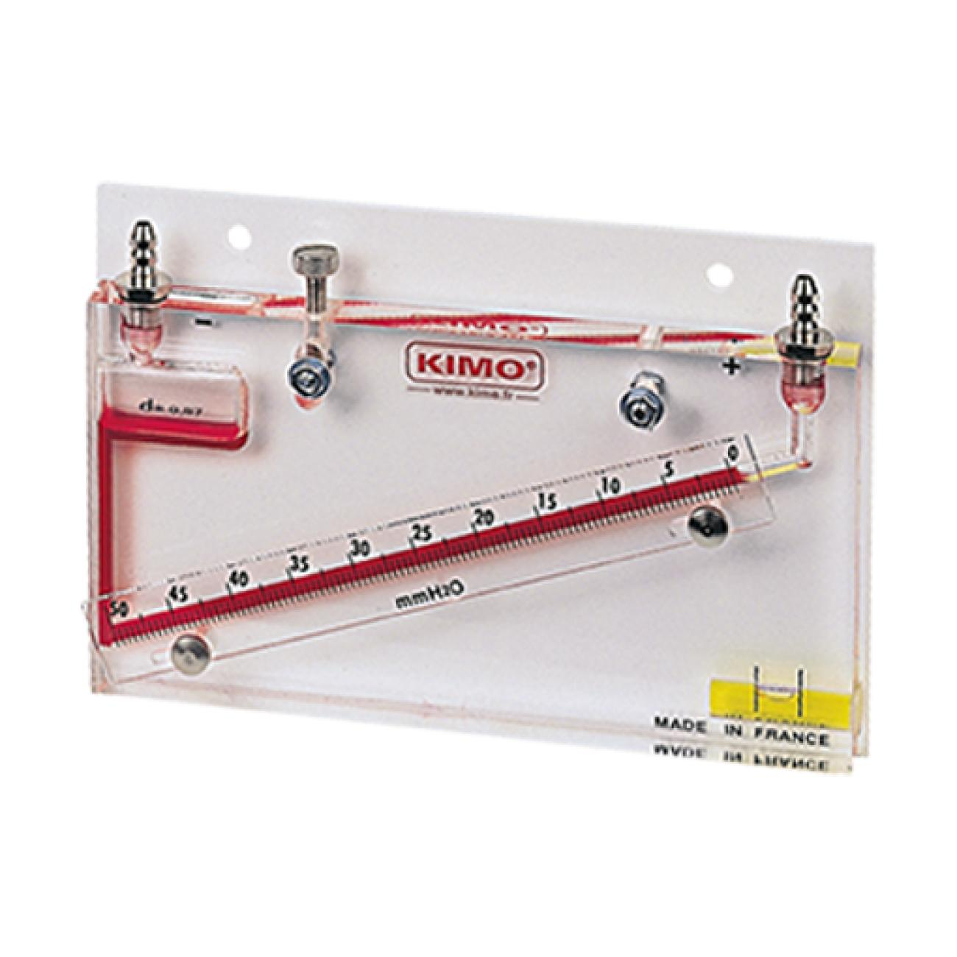
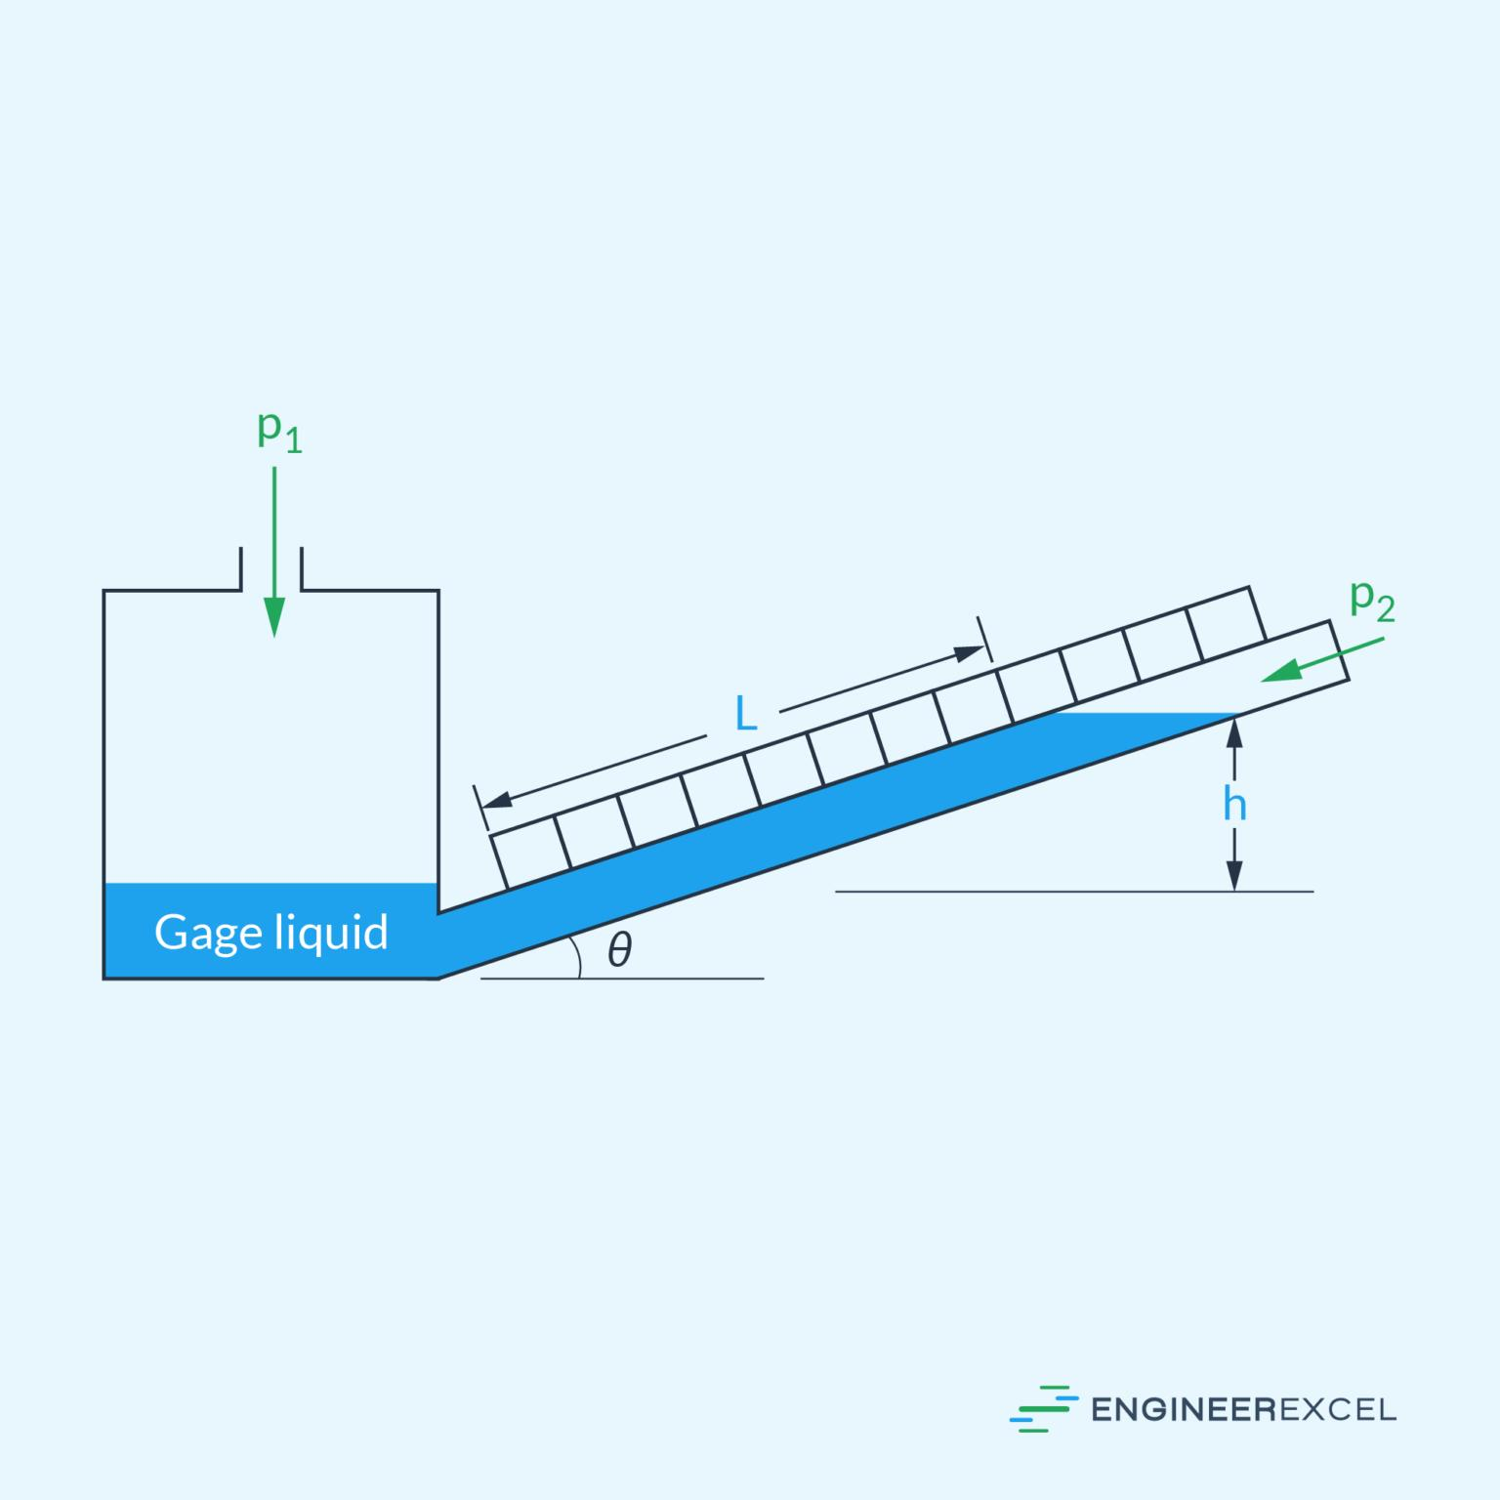
Description
A manometer with an inclined measuring tube that increases sensitivity for measuring very small pressure differences.
Applications
- HVAC systems
- Airflow measurement
- Low-pressure gas systems

3. Well-Type Manometer
# Source: AI Source: Provided by: [Data Path: Persons Table -> ID Column: 1, Name_En Column: Motasem Essam] -> From: [ChatGPT] on [7/17/2026]

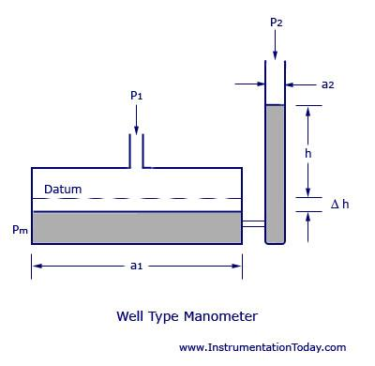
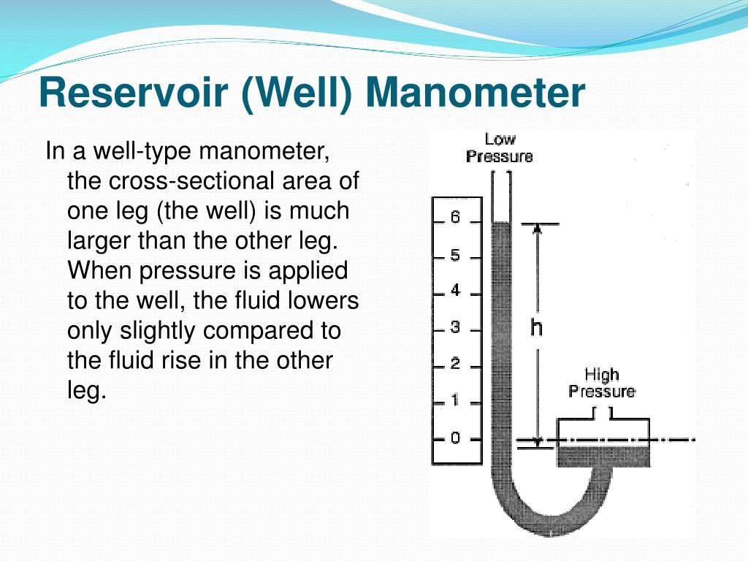
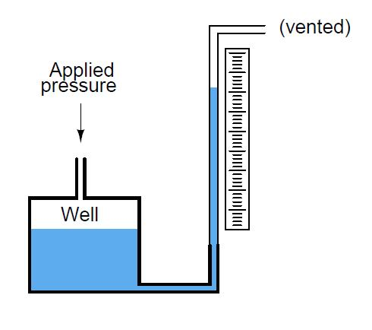
Description
Features a large reservoir (well) connected to a narrow measuring tube, simplifying pressure readings.
Applications
- Pressure calibration
- Laboratory measurements
- Industrial testing

4. Differential Manometer
# Source: AI Source: Provided by: [Data Path: Persons Table -> ID Column: 1, Name_En Column: Motasem Essam] -> From: [ChatGPT] on [7/17/2026]
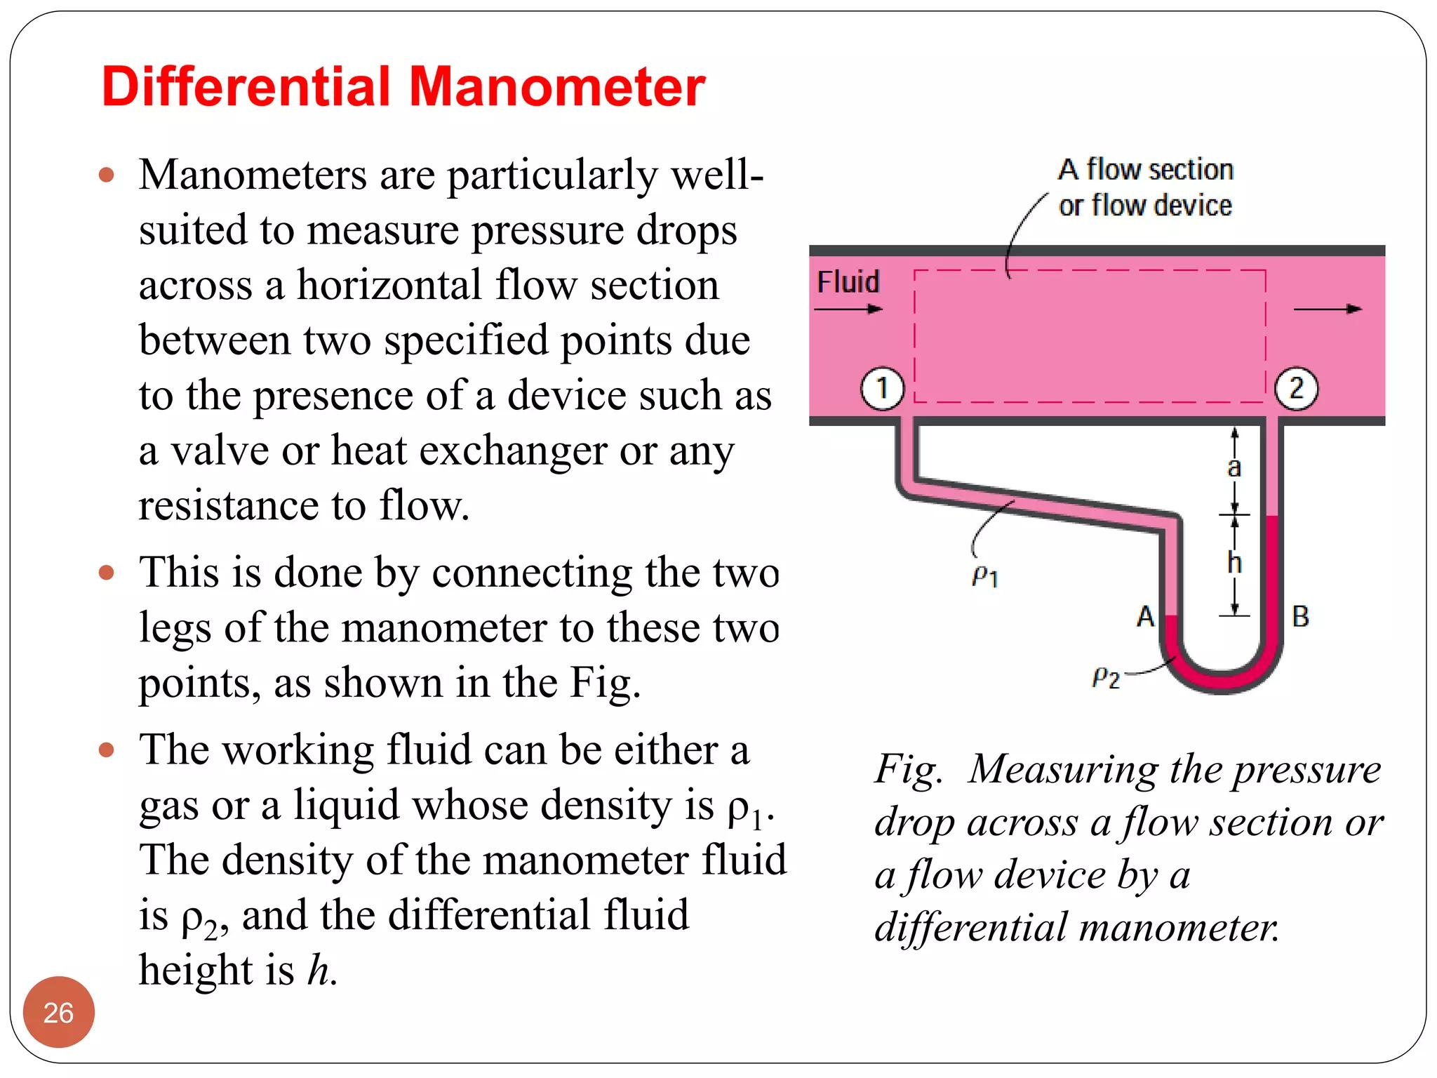

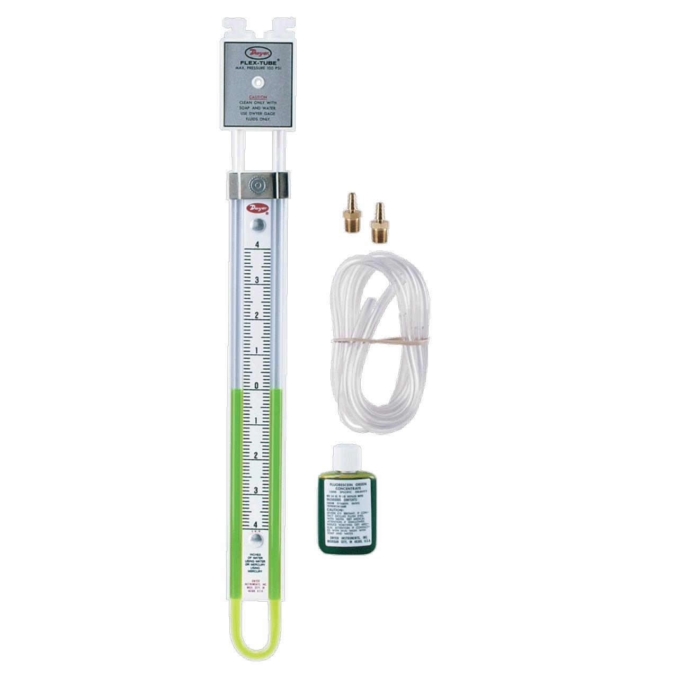
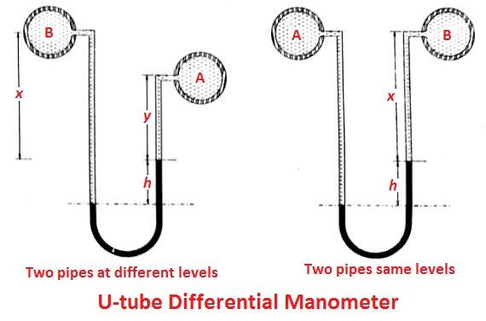
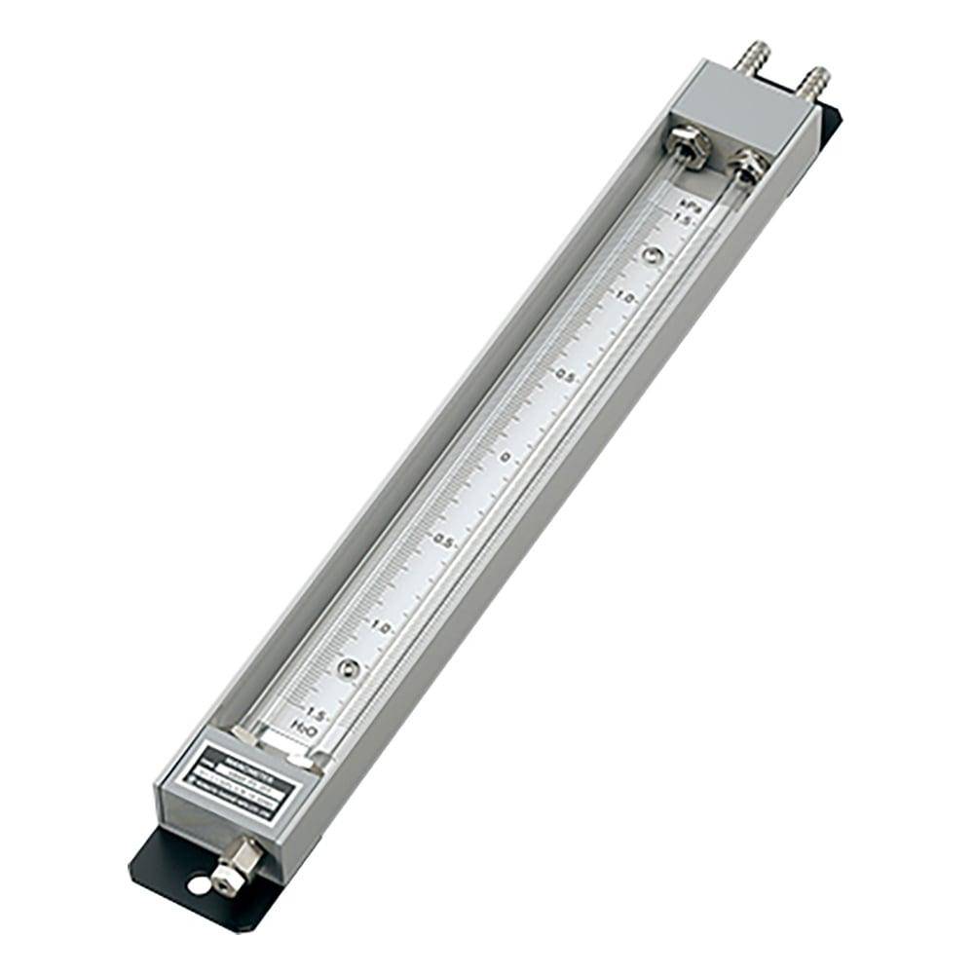
Description
Measures the pressure difference between two separate pressure points.
Applications
- Filter monitoring
- Flow measurement
- HVAC systems
- Process control

5. Digital Manometer
# Source: AI Source: Provided by: [Data Path: Persons Table -> ID Column: 1, Name_En Column: Motasem Essam] -> From: [ChatGPT] on [7/17/2026]
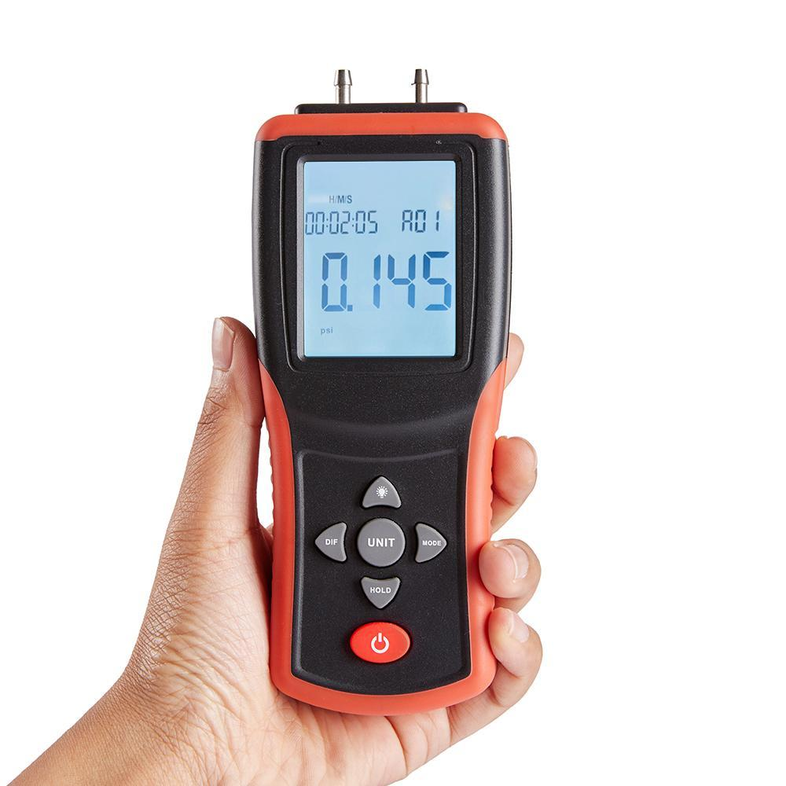
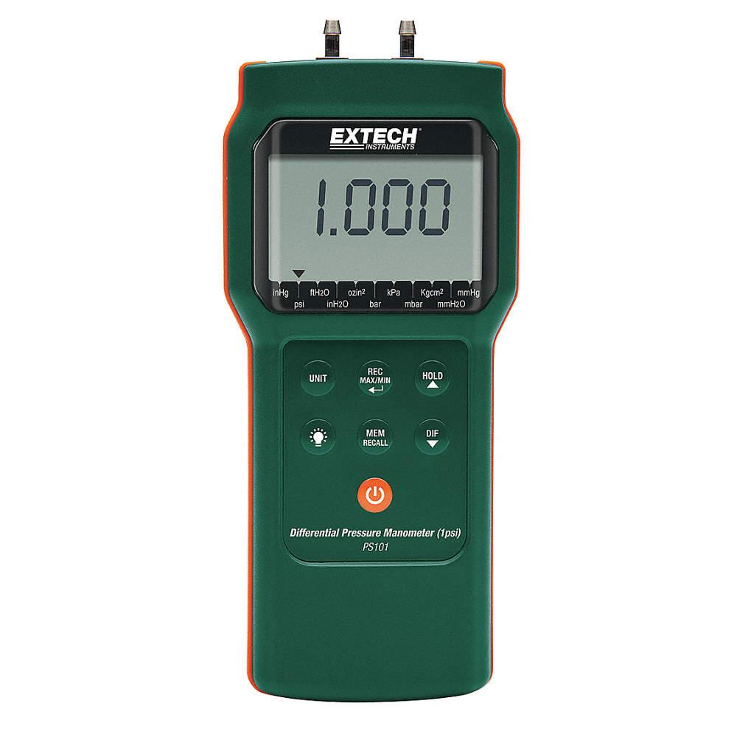
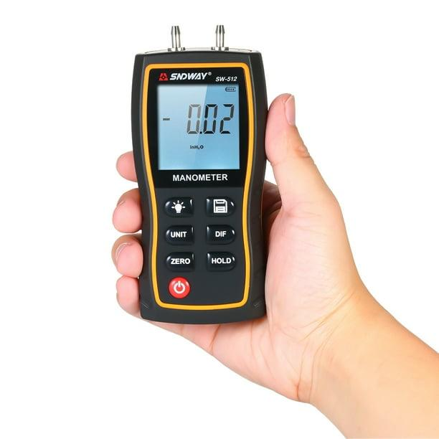
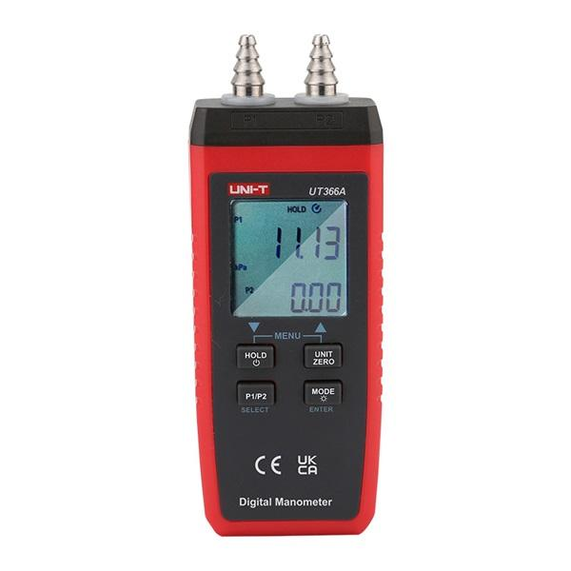
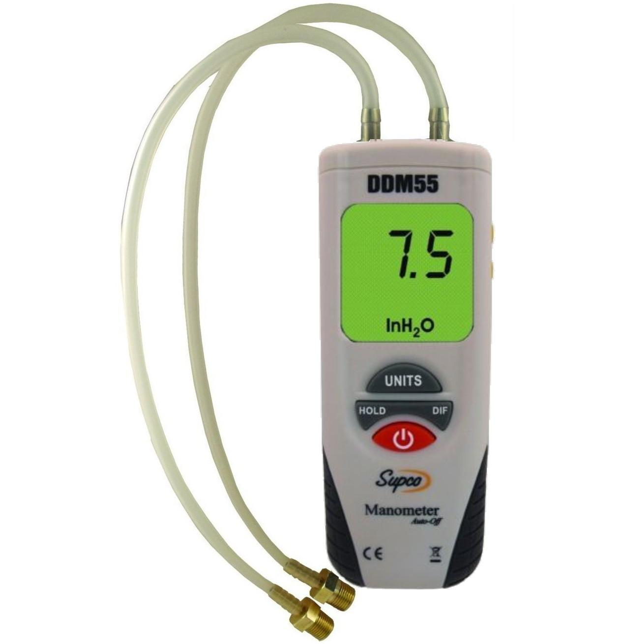
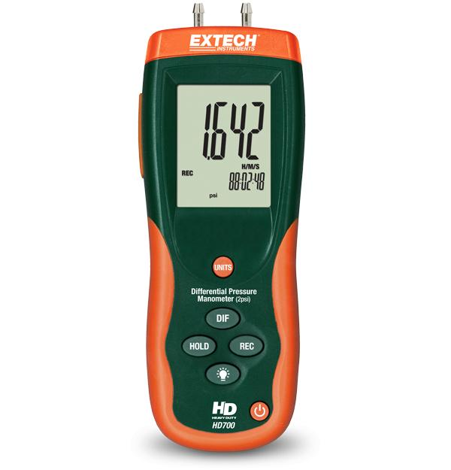
Description
Uses an electronic pressure sensor instead of a liquid column and displays the pressure on a digital screen.
Applications
- Industrial maintenance
- Laboratories
- HVAC servicing
- Calibration work

Measuring Units
# Source: AI Source: Provided by: [Data Path: Persons Table -> ID Column: 1, Name_En Column: Motasem Essam] -> From: [ChatGPT] on [7/17/2026]
Manometers commonly display:
- Pascal (Pa)
- Kilopascal (kPa)
- Millibar (mbar)
- Bar
- psi
- mmH₂O
- cmH₂O
- mmHg
- inH₂O

Measuring Range
# Source: AI Source: Provided by: [Data Path: Persons Table -> ID Column: 1, Name_En Column: Motasem Essam] -> From: [ChatGPT] on [7/17/2026]
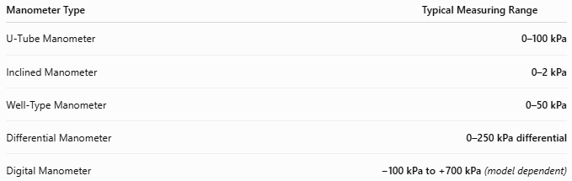
Manometer Type | Typical Measuring Range
U-Tube Manometer | 0–100 kPa
Inclined Manometer | 0–2 kPa
Well-Type Manometer | 0–50 kPa
Differential Manometer | 0–250 kPa differential
Digital Manometer | −100 kPa to +700 kPa (model dependent)

Resolution
# Source: AI Source: Provided by: [Data Path: Persons Table -> ID Column: 1, Name_En Column: Motasem Essam] -> From: [ChatGPT] on [7/17/2026]
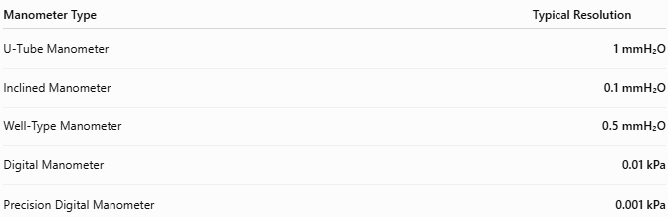
Manometer Type | Typical Resolution
U-Tube Manometer | 1 mmH₂O
Inclined Manometer | 0.1 mmH₂O
Well-Type Manometer | 0.5 mmH₂O
Digital Manometer | 0.01 kPa
Precision Digital Manometer | 0.001 kPa

Accuracy
# Source: AI Source: Provided by: [Data Path: Persons Table -> ID Column: 1, Name_En Column: Motasem Essam] -> From: [ChatGPT] on [7/17/2026]
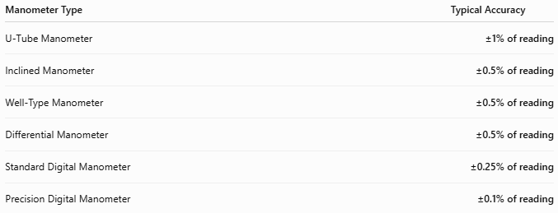
Manometer Type | Typical Accuracy
U-Tube Manometer | ±1% of reading
Inclined Manometer | ±0.5% of reading
Well-Type Manometer | ±0.5% of reading
Differential Manometer | ±0.5% of reading
Standard Digital Manometer | ±0.25% of reading
Precision Digital Manometer | ±0.1% of reading
Notes
- Liquid manometers are extremely reliable because they are based on hydrostatic principles.
- Inclined manometers provide the highest sensitivity for very low pressures.
- Digital manometers offer higher resolution and easier reading than liquid-column models.
- Accuracy depends on correct leveling, calibration, and the density of the working fluid.

How to Use a Manometer
# Source: AI Source: Provided by: [Data Path: Persons Table -> ID Column: 1, Name_En Column: Motasem Essam] -> From: [ChatGPT] on [7/17/2026]
- Connect the pressure ports.
- Ensure the instrument is level (liquid manometers).
- Apply pressure.
- Read the liquid height difference or digital value.
- Convert to the required pressure unit if necessary.

Applications
# Source: AI Source: Provided by: [Data Path: Persons Table -> ID Column: 1, Name_En Column: Motasem Essam] -> From: [ChatGPT] on [7/17/2026]
Manometers are used in:
- Laboratories
- HVAC systems
- Pressure calibration
- Industrial process control
- Gas systems
- Airflow measurement
- Research
- Fluid mechanics

Advantages
# Source: AI Source: Provided by: [Data Path: Persons Table -> ID Column: 1, Name_En Column: Motasem Essam] -> From: [ChatGPT] on [7/17/2026]
A manometer:
- Provides highly accurate pressure measurements.
- Is simple to operate.
- Requires little maintenance.
- Liquid models require no electrical power.
- Digital models offer fast and easy readings.

Limitations
# Source: AI Source: Provided by: [Data Path: Persons Table -> ID Column: 1, Name_En Column: Motasem Essam] -> From: [ChatGPT] on [7/17/2026]
A manometer:
- Liquid models must remain upright.
- Mercury manometers require careful handling.
- Liquid columns are unsuitable for vibration.
- Digital models require batteries.

Sources of Error
# Source: AI Source: Provided by: [Data Path: Persons Table -> ID Column: 1, Name_En Column: Motasem Essam] -> From: [ChatGPT] on [7/17/2026]
Instrument Errors
- Calibration drift
- Incorrect liquid density
- Damaged measuring tube

User Errors
- Incorrect leveling
- Parallax when reading the liquid level
- Improper connections

Environmental Errors
- Temperature changes
- Vibration
- Evaporation of working fluid
- Air bubbles

Comparison with Other Pressure Measuring Instruments
# Source: AI Source: Provided by: [Data Path: Persons Table -> ID Column: 1, Name_En Column: Motasem Essam] -> From: [ChatGPT] on [7/17/2026]
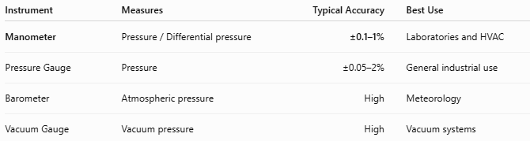
Instrument | Measures | Typical Accuracy | Best Use
Manometer | Pressure / Differential pressure | ±0.1–1% | Laboratories and HVAC
Pressure Gauge | Pressure | ±0.05–2% | General industrial use
Barometer | Atmospheric pressure | High | Meteorology
Vacuum Gauge | Vacuum pressure | High | Vacuum systems

Care and Maintenance
# Source: AI Source: Provided by: [Data Path: Persons Table -> ID Column: 1, Name_En Column: Motasem Essam] -> From: [ChatGPT] on [7/17/2026]
To maintain accuracy:
- Keep the measuring tube clean.
- Prevent leakage of the working fluid.
- Store upright.
- Calibrate digital models periodically.
- Replace contaminated working fluid when necessary.

Common Mistakes
# Source: AI Source: Provided by: [Data Path: Persons Table -> ID Column: 1, Name_En Column: Motasem Essam] -> From: [ChatGPT] on [7/17/2026]
- Reading the liquid level at an angle.
- Using the wrong working fluid.
- Failing to level the instrument.
- Ignoring temperature effects.

Key Points
# Source: AI Source: Provided by: [Data Path: Persons Table -> ID Column: 1, Name_En Column: Motasem Essam] -> From: [ChatGPT] on [7/17/2026]
- A Manometer measures pressure by balancing it against a liquid column or using an electronic sensor.
- Common types:
  - U-Tube Manometer
  - Inclined Manometer
  - Well-Type Manometer
  - Differential Manometer
  - Digital Manometer
- Common units:
  - Pa
  - kPa
  - bar
  - psi
  - mmH₂O
  - mmHg

Conclusion
# Source: AI Source: Provided by: [Data Path: Persons Table -> ID Column: 1, Name_En Column: Motasem Essam] -> From: [ChatGPT] on [7/17/2026]
A Manometer is a precise pressure-measuring instrument used for measuring gas, liquid, vacuum, and differential pressures. Available in both liquid-column and digital forms, it is widely employed in laboratories, HVAC systems, industrial process control, calibration, and fluid mechanics due to its accuracy, simplicity, and reliability.

